Tutorial 4 – Placing Collectables

In this tutorial I will show you how to take the collectables from the previous tutorial and place them down in front of the player.

1. Create an empty object as a child of the player gameobject and rename it to Firepoint.

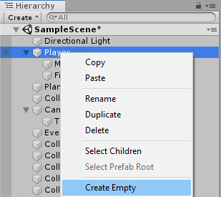

1. Drag one of the Collectables from the hierarchy into the project window below to create a Prefab object.

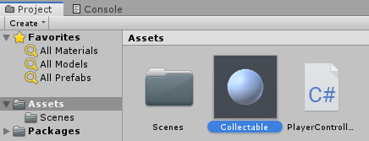

1. Open the PlayerController script once more and add a public GameObject reference called collectable, also create a reference to the gameobject firepoint.

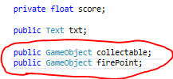

1. In update section of the script create a new if loop for when the player pressed down the mouse 1 key(right mouse button).



1. Now we have the input if statement we can create another if statement that will check if we have enough collectables picked up to place another down. Then within that we will Instantiate (Create) a collectable from the firepoint we referenced earlier. We will also remove one point from the score so that we cannot infinitely spawn collectables.

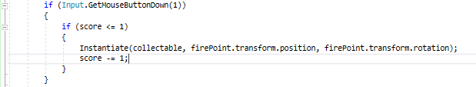

1. Finally, we will go into the player objects inspector and drag the firepoint and collectable prefabs into their respective boxes in the script and move the firepoint a small distance infront of the player so that the player doesn’t instantly pick up the object after placing it down.

